We
Company Name | Marine Rescue Technologies Ltd
Postal Address | Unit J2, Anlaby Trade Park, Springfield Way
Postcode | HU10 6RJ
City | Hull
Telephone Number | +44 (0)1482 679300
Email address | smrtcustomerservice@wescom-group.com
Declares under its sole responsibility that the product(s) as originally delivered:
Product Name(s) | sMRT V300
Model Number(s) | MOA-50075
Batch Number(s) | N/A
Serial Number(s) | N/A
Comply with the essential requirements of the following applicable European Directives, and carry the CE mark accordingly:
EMC & Radio Performance | The Radio Equipment Directive 2014/53/EU
Safety | The Low Voltage Directive 2014/35/EU
The following harmonised standards and technical specifications have been applied:
ETSI EN 301 843-8 v1.1.1 (draft) | RED article 3.1(b)
ETSI EN 301 843-1 v2.3.1 (draft) | RED article 3.1(b)
EN 60945:2002 | EMC
ETSI EN 303 132 V2.1.1 | RED articles 3.2 & 3.3(g)
ETSI EN 300 330 V2.1.1 | RED article 3.2
EN 62368-1:2020+A11:2020 | Safety
EN 62311:2020 & EN 62479:2010 | RF exposure

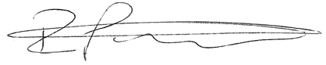
Signed on behalf of Marine Rescue Technologies Ltd:
Date | Name | Position | Signature
15th October 2024 | Ryan Pettit | Managing Director

 | 

